Day One: Linear and Exponential Group Test

1. Directions: Make a perfect graph of the number of people who walk to school.

x (year) | y (number of people)
0 | 3
1 | 7
2 | 5
3 | 10
4 | 13

2. Use colors, numbers, words, and arrows to show growth rate and starting number in all of these representations.
$$y=2{(1.5)}^{x}$$
x | y
0 | 2
1 | 3
2 | 4.5
3 | 6.75

3. Directions: Sarah evaluated this function: y = 5x + 4 for x = 2. Explain her steps.
“First, __________.” “Next, _________.” “Then, ________.” “Finally, ________.”

y = 5x + 4
y = (5)(2) + 4
y = 10 + 4
y = 14

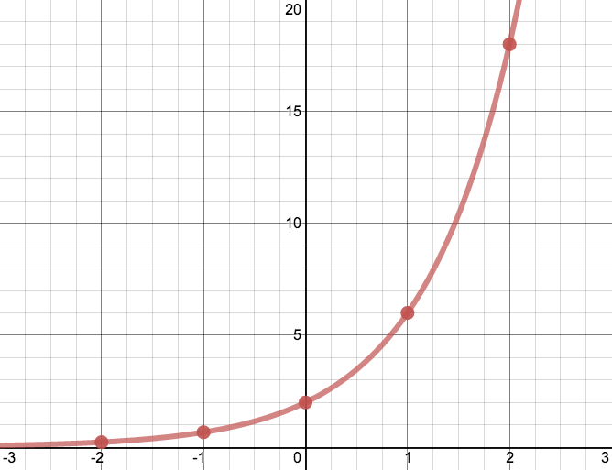
4. Directions: Here is a table, graph and equation. Ms. Tara says it is an exponential function. Ms. Jess says it is a linear function.
Who is correct? Why?
“_______ is correct because ________.”
y = 2(3)^{x}

x | y
0 | 2
1 | 6
2 | 18
3 | 54
4 | 162
5 | 486

__________________________________________________________________________________________________________________________________________________________________________________________________________________________________________________
_________________________________________________________________________________________________________________________________________________________________________________________________________________________________________________

5. This graph shows the temperature in the country Albania each month.
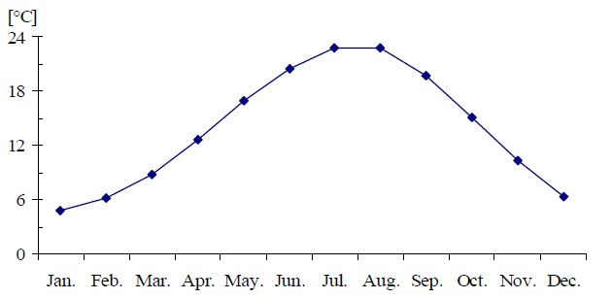
Temperature in Albania
Months
Temperature in °C

This data is not perfect, but the equation $y=3x+4.5$ is close. Use the equation to make a prediction for the temperature in July.
I think the temperature in July will be _______ because …
__________________________________________________________________________________________________________________________________________________________________________________________________________________________________________________
Can we use this equation to make a prediction for December? Why or why not?
I think we ___________ use the equation to make a prediction for December because…
__________________________________________________________________________________________________________________________________________________________________________________________________________________________________________________

Day 2: Linear and Exponential Test Checklist Box

Question One
- Three titles, x and y, arrows on axes
- Good numbers
- Points are correct

Question Two
- Colors show growth and starting number
- Two colors on the graph, equation, table

Question Three
- Explain where the x number comes from
- Explains multiplying
- Math words: first, next, then, finally, add, multiply, equation

Question Four
- Exponential is correct
- Explains table, graph, equation
- Uses math words: curved, adding, table, graph, equation, exponent

Question Five
- Uses equation to get a number for July
- Explains calculation
- Explains December

Day 2: Linear and Exponential Test Review
- Make a dictionary to use on the test
Say: “Let’s look at Question 1. Are there any words you don’t know?”

Do: Write and translate into ML words you do not know on the test.

Repeat this for all the questions.
Call the teacher when everyone is done!
“Excuse me, we are done!”

- Make a perfect test
Say: “What did you get for number 1? Do we agree?”

Do: If you disagree, look at both papers and talk until you agree.

Say: “What do we need to write to get a 4?”

Do: Read the checklist box. To get a “4,” check ALL the boxes. If you do not have all the boxes, make a perfect answer. If you have all the boxes, go to the next question.

Repeat this for all the questions.
Call the teacher when everyone is done!
“Excuse me, we are done!”

- Check your writing: periods for each sentence, capital letters for each sentence
Say: “Can I check your work? Do you have periods and capital letters?”

Do: Check that all words are in English. Check that every sentence has a capital letter and a period.

Repeat this for all the questions.
Call the teacher when everyone is done!
“Excuse me, we are done!”

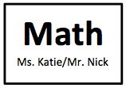
Day 2: Linear and Exponential Test Dictionary

English | ML |  | English | ML

Day 3: Exponential and Linear Functions - Individual Test

1. Directions: Make a perfect graph of the number of people who take the bus to school.

x (month) | y (number of people)
0 | 17
1 | 27
2 | 34
3 | 12
4 | 22

2. Use colors, numbers, words, and arrows to show growth rate and starting number in all of these representations.
$$y=4{(2)}^{x}$$
x | y
0 | 4
1 | 8
2 | 16
3 | 32

3. Directions: Sarah evaluated this function: y = 3(6)^{x} for x = 2. Explain her steps.
“First, __________.” “Next, _________.” “Then, ________.” “Finally, ________.”

y = 3(6)^{x}
y = 3(6)²
y = 3(6$∙$6)
y = 3(36)
y = 108

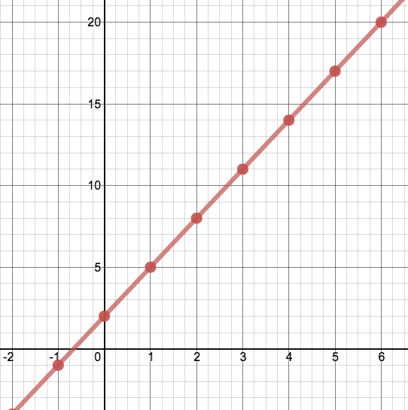
4. Directions: Here is a table, graph and equation. Ms. Tara says it is an exponential function. Ms. Jess says it is a linear function.
Who is correct? Why?
“_______ is correct because ________.”
y = 2 + 3x

x | y
0 | 2
1 | 5
2 | 8
3 | 11
4 | 14
5 | 17

__________________________________________________________________________________________________________________________________________________________________________________________________________________________________________________
_________________________________________________________________________________________________________________________________________________________________________________________________________________________________________________

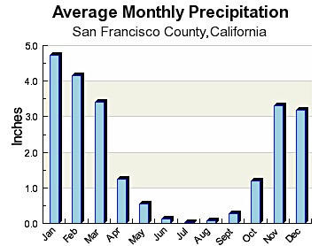
5. This graph shows the rainfall in San Francisco each month.
0 1 2 3 4 5 6 7 8 9 10 11
months

This data is not perfect, but the equation $y=-0.5x+4.75$ is close. Use the equation to make a prediction for the temperature in July.
I think the rainfall in July will be _______ because …
__________________________________________________________________________________________________________________________________________________________________________________________________________________________________________________
Can we use this equation to make a prediction for December? Why or why not?
I think we ___________ use the equation to make a prediction for December because…
__________________________________________________________________________________________________________________________________________________________________________________________________________________________________________________

